 **Methods 11 Test 2 2017**

**Quadratic and Linear Functions**

**Total Marks: 60 Time Allowed: 60 minutes**

**Name: _______________________**

**SECTION A – Resource Free**

**40 minutes – 39 marks**

**ALL** working must be shown for full marks.

**1.** **[3, 1, 2 = 6 marks]**

A parabola has the equation y = (x – 2)(5 – x).

a) Find the coordinates of the x and y intercepts of the parabola.

b) Find the equation of the line of symmetry

c) Find the coordinates of the turning point of the parabola and state the nature of the turning point.

**2. [8 marks]**

Complete the following table with the appropriate information.

|  |  |  |  |  |
| --- | --- | --- | --- | --- |
|  | **x–intercept** | **y-intercepts** | **Domain** | **range** |
|  |  |  |  |  |
|  |  |  |  |  |

**3.** **[8 marks]**

Find the equation defining the parabola that passes through (2, -3) (5, 15) (3, 1)

**4. [3, 2, 2 = 7 marks]**

The lines 2x + 3y = 12 and 4x + 5y = 20 meet at the point P.

a) Find the coordinates of P.

b) Find the equation of the line through P and parallel to the line with equation 2x + y = 10.

c) Find the equation of the line through P and perpendicular to the line with equation 2x + y = 10.

d) Write the equation of this function if it passes through the point (3, 5).

**5. [2, 2, 2 = 6 marks]**

a) Find the value(s) for k for which x² - 10x + k = 0 has exactly one solution.

b) Find the value(s) for k for which 2x² + 5x – k = 0 has real solutions.

c) Find the value(s) for k for which kx² + 6x – 2 = 0 has no real solutions.

**6. [1, 1, 1, 1 = 4 marks]**

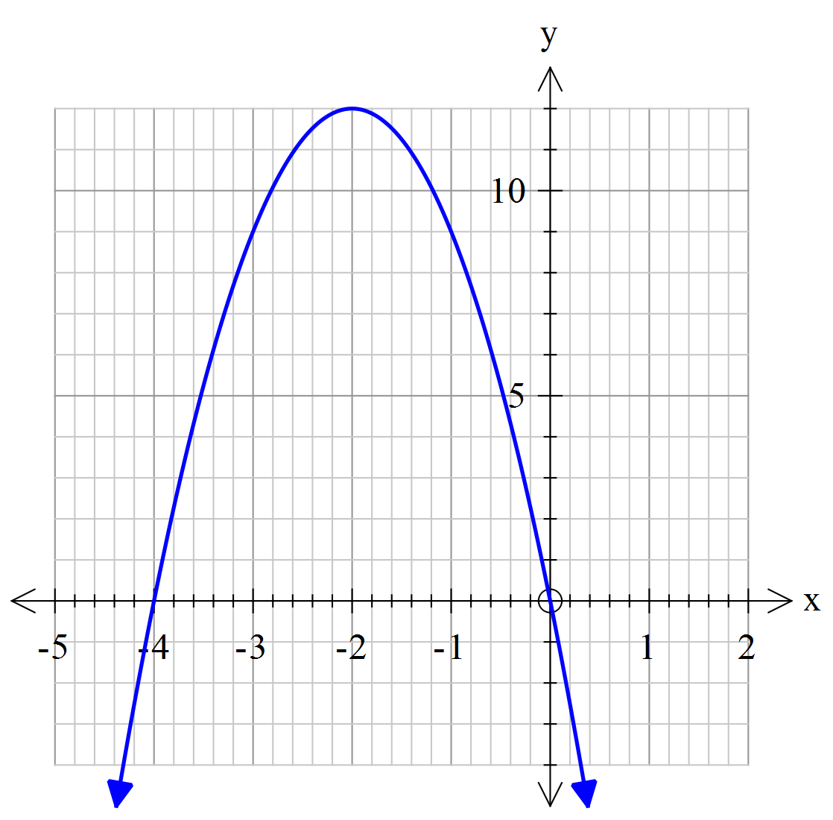

Consider the graph of y = f(x) shown.

Find the image of the point (-3, 9) under

the following transformations:

a) y = f(x+3)

b) y = f(-x)

c) y = f(2x) + 1

d) y = -2f(x)

**Methods 11 Test 2 2017 (functions)**

**Total Marks: 60 Time Allowed: 60 minutes**

**Name: _______________________**

**SECTION B – Calculators**  **20 minutes – 21 marks**

**7.** **[6 marks]**

Match the graphs with the equations.

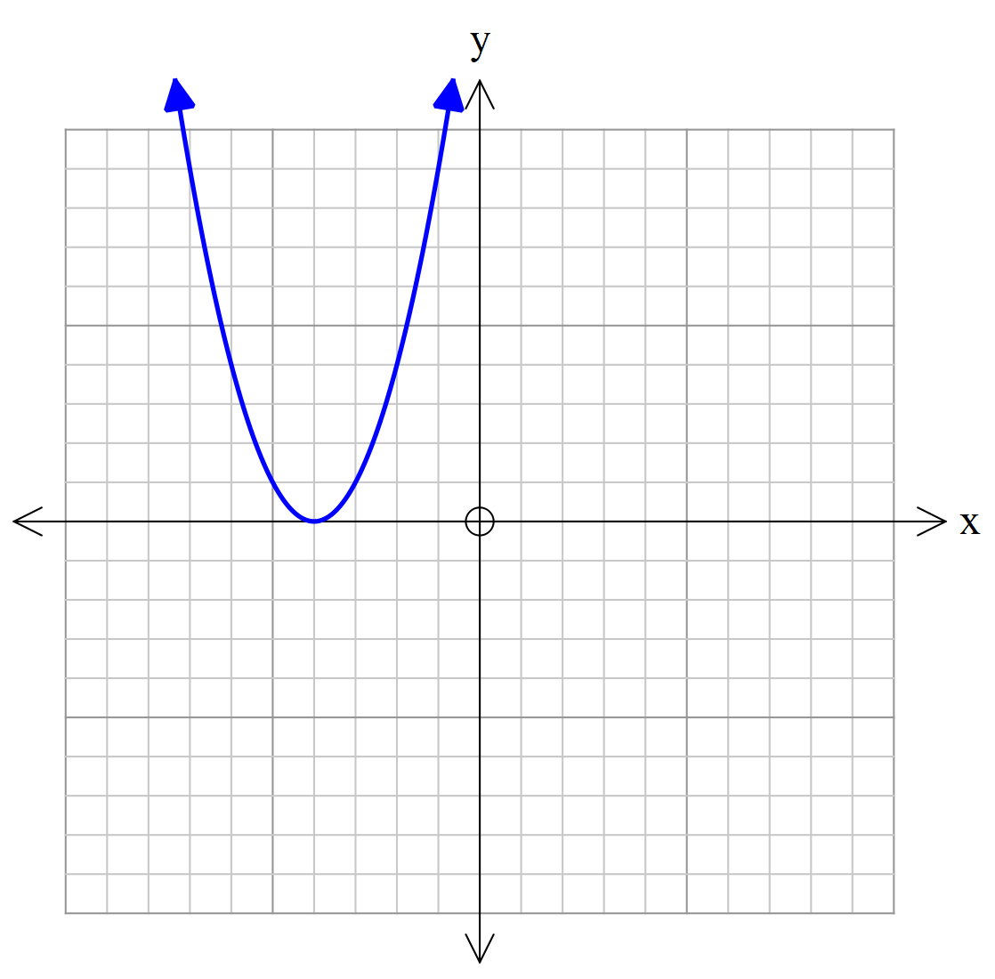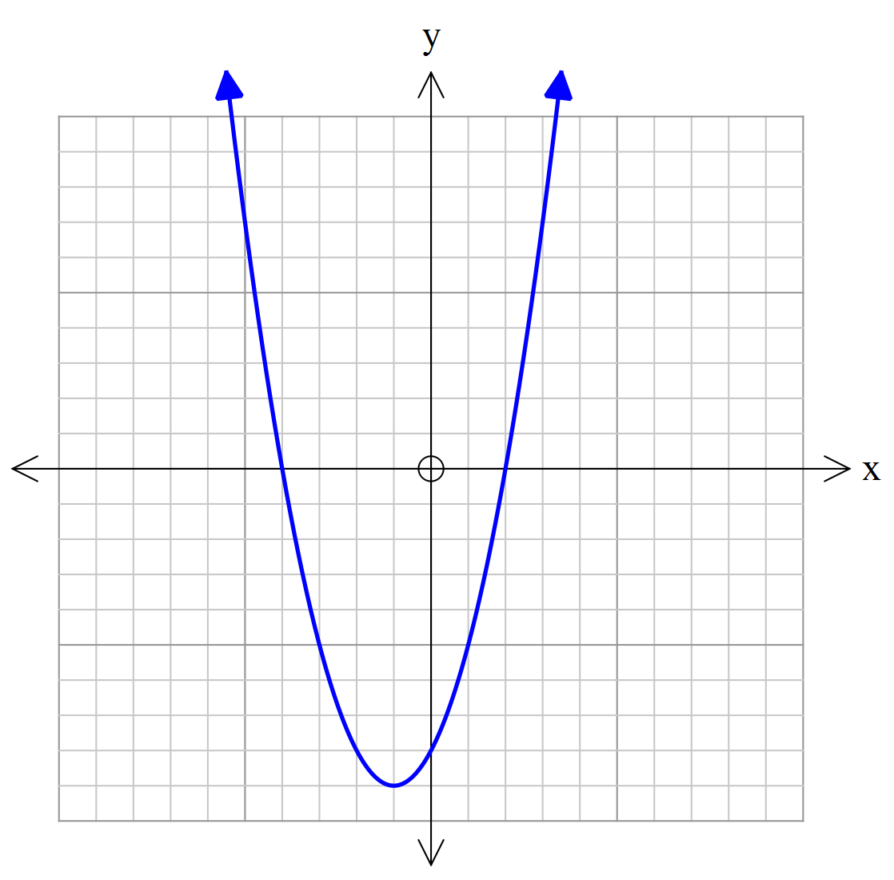

A

B

C

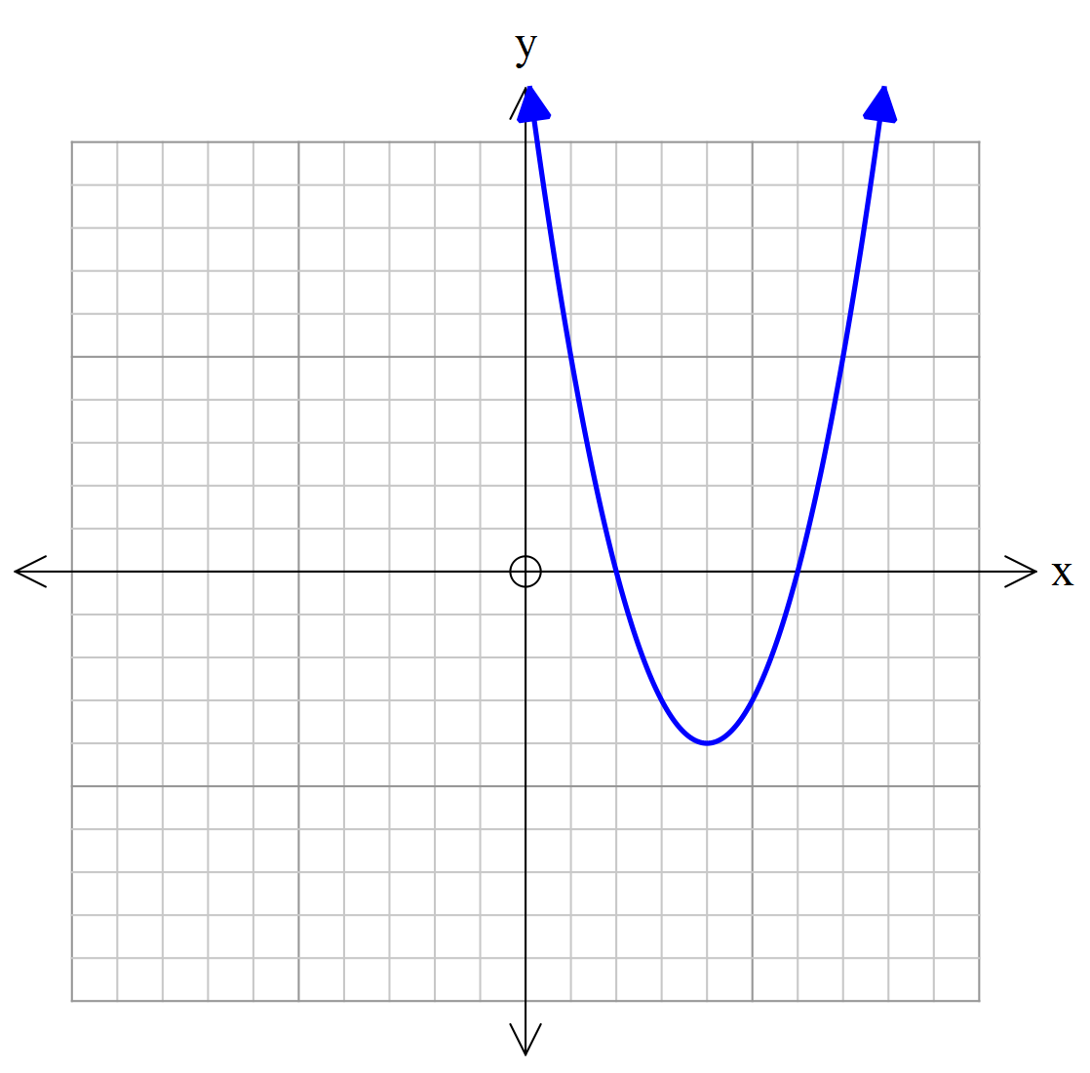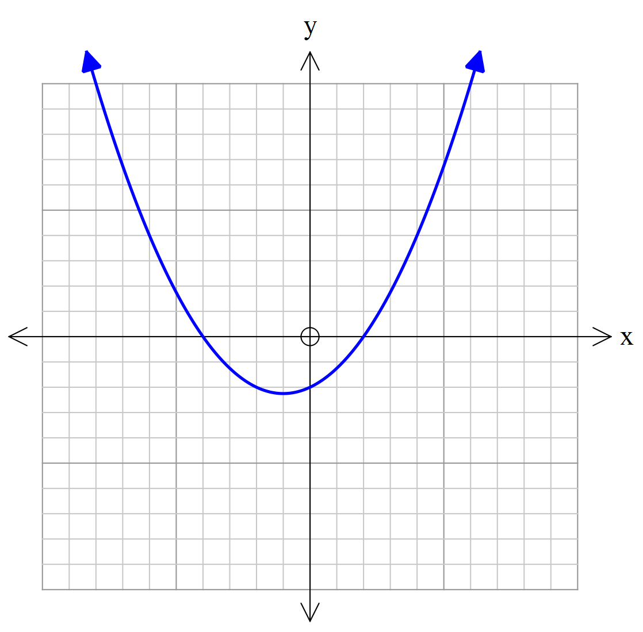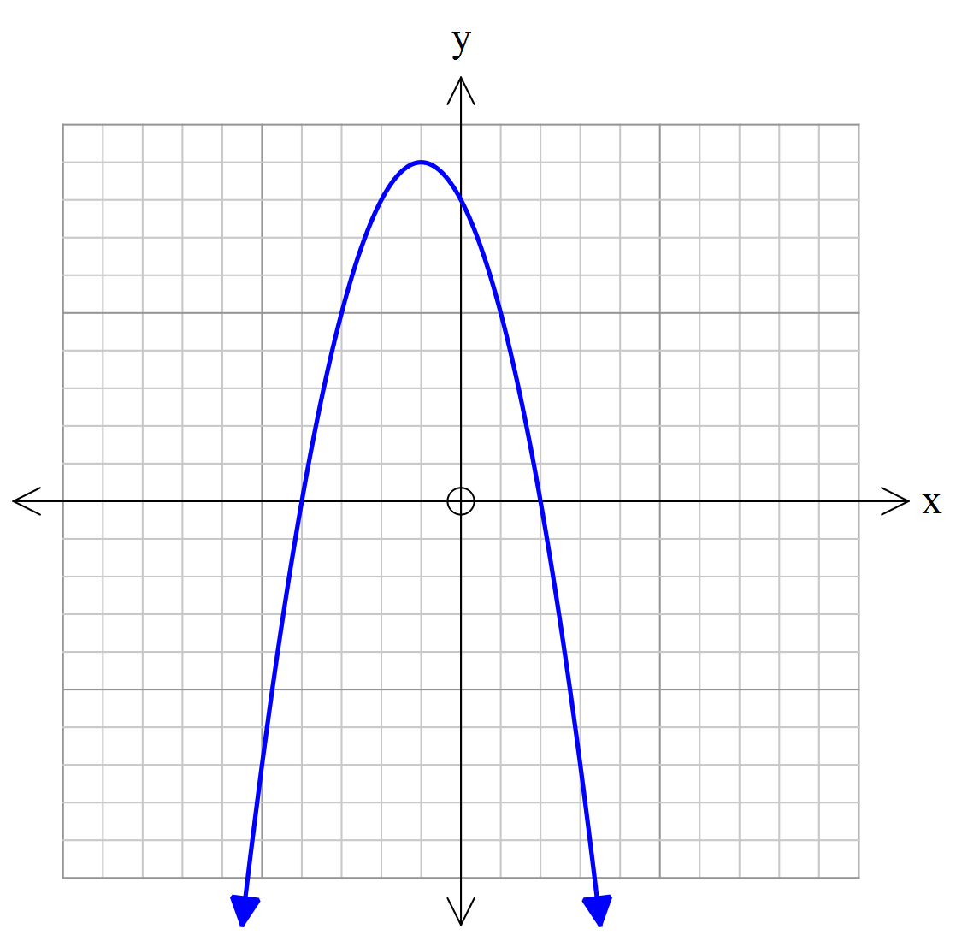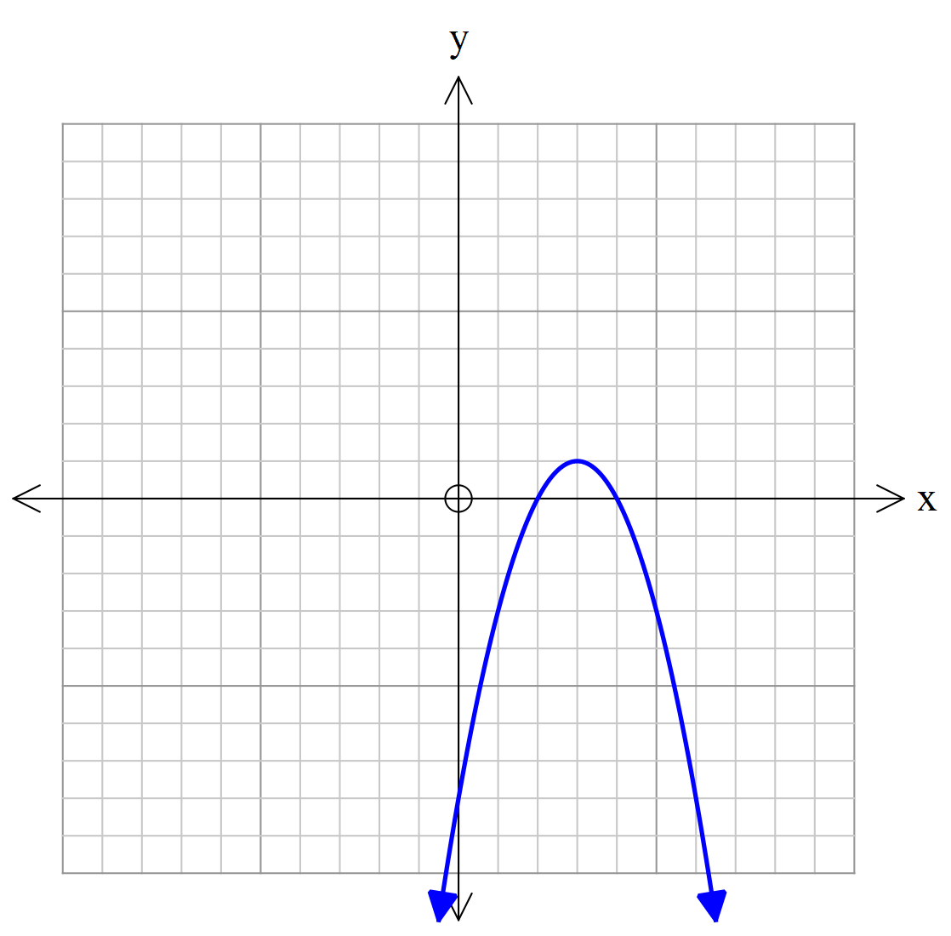

D

E

F

**y = a(x-b)(x+a) Graph _________ y = (x-a)(x-b) Graph ___________**

**y = (x+a)² Graph _________ y = x²-bx – c Graph ___________**

**y = -x²+bx+c Graph _________ y=-(x-a)²+b Graph ___________**

**8.** **[1, 1, 3, 4 = 9 marks]**

Kaleb, the TV installer charges a call-out fee of $100 plus $80 per half hour or part thereof. Callum, another TV installer does not charge a call-out fee but charges $180 per hour or part thereof.

a) How much will Kaleb charge for a job that is estimated to take exactly 4 hours?

b) How much will Callum charge for a job that is estimated to take exactly 4 hours?

c) Determine which TV installer will be cheaper to employ if a job is estimated to take 3 hours and 20 minutes. Justify your answer.

d) Under what conditions will it be cheaper to employ Kaleb? Justify your answer.

**9.** **[1, 1, 2, 2 = 6 marks]**

The height (h metres) of a soccer ball in flight is given by h = -0.008x(x – 40) for x ≥ 0, where x (metres) is the horizontal distance travelled from the point where the ball was kicked. Assume the ball travels in a vertical plane. Find

a) the maximum height reached by the ball.

b) the horizontal distance travelled by the ball if it was not intercepted during its flight

c) the horizontal distance travelled by the ball if it was caught when it was intercepted at a height of 2 metres.

d) x when the ball was more than 1 metre above the ground